**FIN**

(Friend In Need)

**Prepared** **for**

1. **K. M. Ahsanul Hoque, Assistant professor**

**Tashreef Muhammad, Adjunct Faculty**

**Prepared by**

**Lab Section: B2**

**Kh. Rifat Amin, 180204116**

**Fazlay Elahi Safin, 180204119**

**Sanjida Aziz Tonny, 180204122**

**Md Zahidul Haque, 180204136**

**S.M Tasnimul Hasan, 180204142**

**Date: 15/02/2022**



**Ahsanullah University of Science and Technology**

**Department of Computer Science and Engineering**

**Table of Contents**

|  |  |
| --- | --- |
| **Contents** | **Page no** |
| 1. **Sequence Diagram** | 03 |
| 1. **Collaboration Diagram** | 04 |
| 1. **Data Flow Diagram** | 05 |
| 1. **System Architecture** | 06 |

1. **Sequence Diagram :**

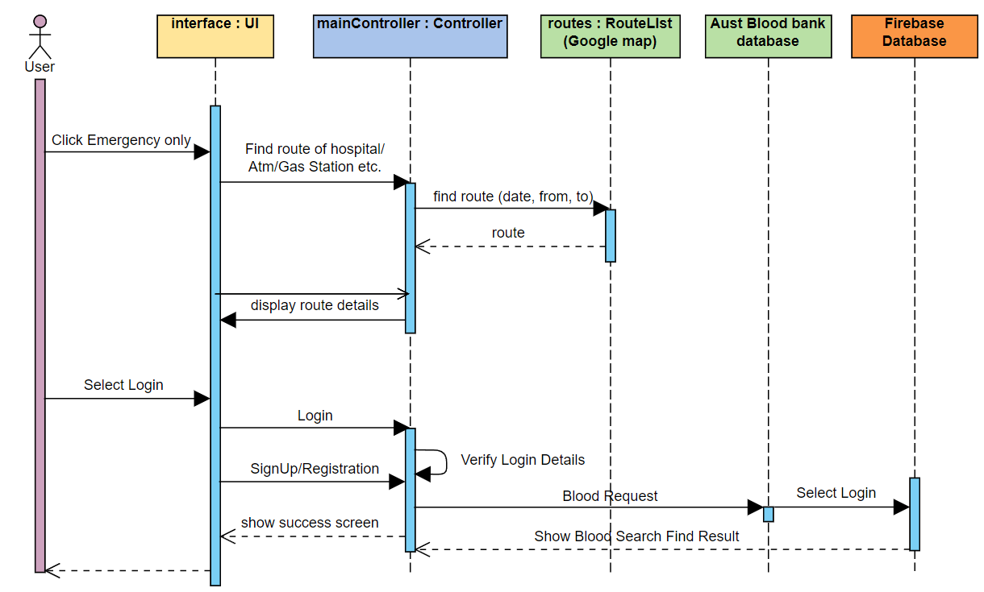

1. **Collaboration Diagram :**

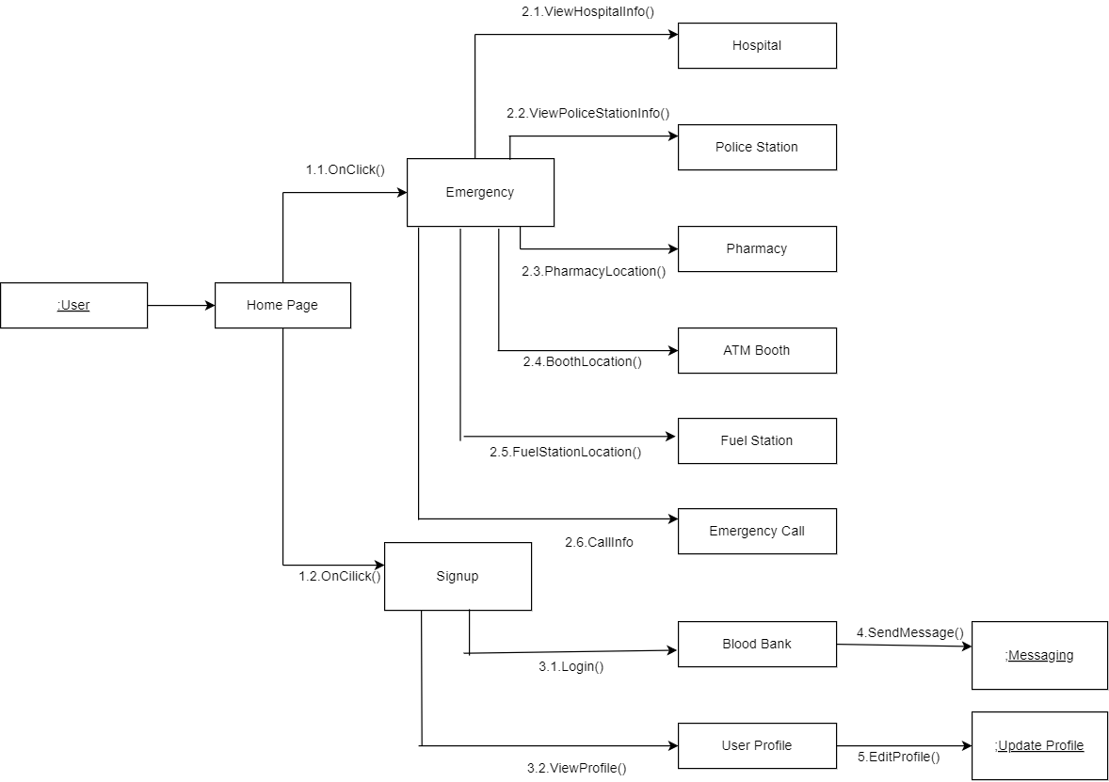

1. **Data Flow Diagram :**

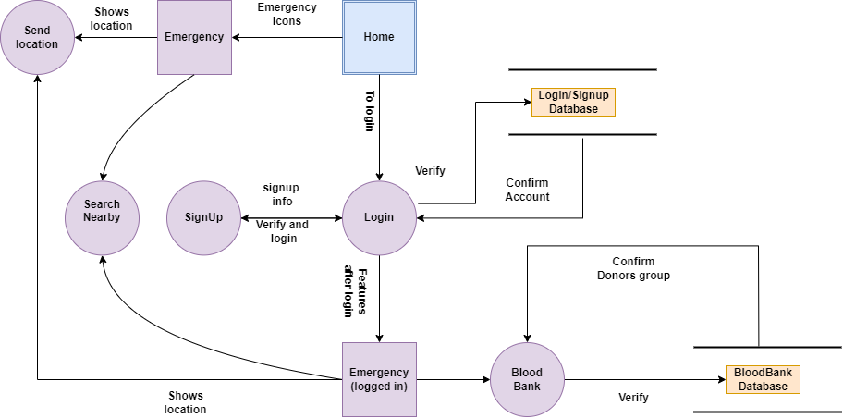

1. **System Architecture :**

